**Syria Profile - Timeline**

25 January 2017

From the section [Middle East](http://www.bbc.com/news/world/middle_east)

Top of Form

Bottom of Form

**A chronology of key events:**

**1918**October - Arab troops led by Emir Feisal, and supported by British forces, capture Damascus, ending 400 years of Ottoman rule.

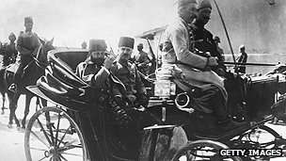

Image copyright GETTY IMAGES Image caption The Ottoman governor of Syria, Jamal Pasha, rides through Damascus in 1917.

**1919**- Emir Feisal backs Arab self-rule at the Versailles peace conference, following the defeat of Germany and the Ottoman Empire in World War I.

**1920**March - National Congress elected the previous year proclaims Emir Feisal King of Syria from the Taurus mountains of Turkey to the Sinai desert in Egypt.

**French control**

**1920**June - San Remo conference puts Syria-Lebanon under a French mandate and Palestine under British control. King Feisal flees abroad ahead of French occupation forces the following month.

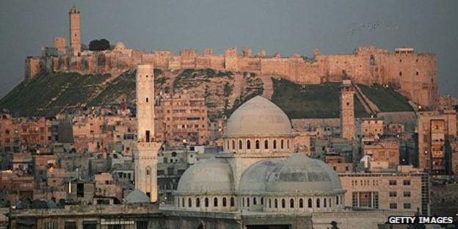

Image copyright GETTY IMAGES Image caption Aleppo, one of the oldest continuously inhabited cities, was badly damaged during the civil war after 2011

**1920-21**- Syria is divided into three autonomous regions by the French, with separate areas for the Alawis on the coast and the Druze in the south. Lebanon is separated off entirely.

**Uprising**

**1925-6** - Nationalist agitation against French rule develops into uprising. French forces bombard Damascus.

**1928**- Elections held for a constituent assembly, which drafts a constitution for Syria. French High Commissioner rejects the proposals, sparking nationalist protests.

**1936**- France agrees to work towards Syrian independence and dissolves the autonomous regions, but maintains military and economic dominance and keeps Lebanon as a separate state.

**1941**- British and Free French troops occupy Syria. General De Gaulle promises to end the French mandate.

**1943** - Veteran nationalist Shukri al-Kuwatli is elected first president of Syria, leads the country to full independence three years later.

**Baath Party founded**

**1947**- Michel Aflaq and Salah-al-Din al-Bitar found the Arab Socialist Baath Party.

**1949-1954**- Civilian government disrupted by repeated coups.

**1955**- Shukri al-Kuwatli returns to power, seeks closer ties with Egypt.

**1958**February - Syria and Egypt form the United Arab Republic. Egyptian president Gamal Abdel Nasser heads the new state. He orders the dissolution of Syrian political parties, to the dismay of the Baath party, which had campaigned for union.

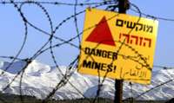

Image copyright AFP Image caption Israel occupied the Golan Heights in 1967 Israel occupied the Golan Heights in 1967 during the Six Day War

[**Golan Heights profile**](http://www.bbc.com/news/world-middle-east-14724842)

**1961**September - Discontent with Egyptian domination prompts a group of Syrian army officers to seize power in Damascus and dissolve the union.

**Rise of Assad**

**1963**March - Baathist army officers seize power.

**1966**February - Salah Jadid leads an internal coup against the civilian Baath leadership. Hafez al-Assad becomes defense minister.

**1967**June - Israeli forces seize the Golan Heights from Syria and destroy much of Syria's air force in the Six Day War with Egypt, Jordan and Syria.

**1970**November - Hafez al-Assad overthrows president Nur al-Din al-Atasi and imprisons Salah Jadid.

**1973**- Rioting breaks out after President Assad drops the constitutional requirement that the president must be a Muslim. Suppressed by the army.

**War with Israel**

**1973**October - Syria and Egypt go to war with Israel, but fail to retake the Golan Heights seized in 1967.

**1975**February - President Assad says he's prepared to make peace with Israel in return for an Israeli withdrawal from "all occupied Arab land".

**1976**June - Syrian army intervenes in the Lebanese civil war to ensure that the status quo is maintained, keeping its Maronite Christian allies in a position of strength.

**Muslim Brotherhood rises**

**1980**- After the Islamic Revolution in Iran, Muslim groups instigate uprisings and riots in Aleppo, Homs and Hama. [**Syria profile**](http://www.bbc.com/news/world-middle-east-14703995)

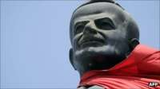

Image copyright AFP

Hafez al-Assad brought stability, but did so through repression

[**Obituary: Syria's shrewd master**](http://news.bbc.co.uk/1/hi/world/middle_east/359051.stm)

[**Syria profile**](http://www.bbc.com/news/world-middle-east-14703995)

**1980**September - Start of Iran-Iraq war. Syria backs Iran, in keeping with the traditional rivalry between Baathist leaderships in Iraq and Syria.

**1981**December - Israel formally annexes the Golan Heights.

**Uprising in Hama**

**1982**February - Muslim Brotherhood uprising in the city of Hama suppressed by army, tens of thousands of civilians killed.

**1982**June - Israel invades Lebanon and attacks the Syrian army, forcing it to withdraw from several areas. Israel attacks the PLO base in Beirut.

**1983**May - Lebanon and Israel announce the end of hostilities. Syrian forces remain in Lebanon.

**1984**- President's brother Rifaat promoted to vice-president.

**Return to Lebanon**

**1987**February - President Assad sends troops into Lebanon for a second time to enforce a ceasefire in Beirut.

**1990**- Iraq invades Kuwait; Syria joins the US-led coalition against Iraq. This leads to improved relations with Egypt and the US.

**1991**October - Syria participates in the Middle East peace conference in Madrid and holds talks with Israel that founder over the Golan Heights issue.

**1994**- President Assad's son Basil, who was likely to succeed his father, is killed in a car accident.

**1998**- President Assad's brother Rifaat is dismissed as vice-president.

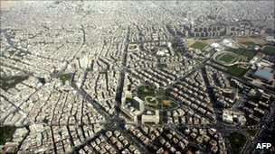

Image copyright AFP Image caption Damascus urban sprawl

**1999**December - Further talks with Israel over the Golan Heights begin in the US, but are indefinitely postponed the following month.

**Assad succession**

**2000**June - President Assad dies and is succeeded by his second son, Bashar.

**2000**November - The new president orders the release of 600 political prisoners.

**2001**April - Outlawed Muslim Brotherhood says it will resume political activity, 20 years after its leaders were forced to flee.

**2001**June - Syrian troops evacuate Beirut, redeploy in other parts of Lebanon, following pressure from Lebanese critics of Syria's presence.

**2001**September - Detention of MPs and other pro-reform activists, crushing hopes of a break with the authoritarian past of Hafez al-Assad. Arrest continue, punctuated by occasional amnesties, over the following decade.

**Tensions with US**

**2002**May - Senior US official includes Syria in a list of states that make-up an "axis of evil", first listed by President Bush in January. Undersecretary for State John Bolton says Damascus is acquiring weapons of mass destruction.

**2004**January - President Assad visits Turkey, the first Syrian leader to do so. The trip marks the end of decades of frosty relations, although ties sour again after the popular uprising in 2011.

**2004**May - US imposes economic sanctions on Syria over what it calls its support for terrorism and failure to stop militants entering Iraq.

**Syria and Lebanon**

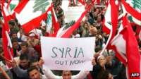

Image copyright AFP

The killing of former Lebanese PM Rafik Hariri sparked anti-Syrian protests in Beirut

[**Syria withdrawal: Lebanese speak**](http://news.bbc.co.uk/1/hi/world/middle_east/4482883.stm)

**2005**February-April- Tensions with the US escalate after the killing of former Lebanese PM Hariri in Beirut. Washington cites Syrian influence in Lebanon. Damascus is urged to withdraw its forces from Lebanon, which it does by April.

**Diplomatic overtures**

**2006**November - Iraq and Syria restore diplomatic relations after nearly a quarter century.

**2007**March - European Union relaunches dialogue with Syria.

**2007**April - US House of Representatives Speaker Nancy Pelosi meets President Assad in Damascus. She is the highest-placed US politician to visit Syria in recent years. Secretary of State Condoleezza Rice meets Foreign Minister Walid Muallem the following month in the first contact at this level for two years.

**Mystery site**

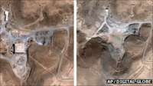

Image copyright AP

Israeli forces destroyed what they said was a nuclear facility under construction. Syria says it was an unused military facility

**2007**September - Israel carries out an aerial strike against a nuclear facility under construction in northern Syria.

**2008**July - President Assad meets French President Nicolas Sarkozy in Paris. The visit signals the end of the diplomatic isolation by the West that followed the assassination of former Lebanese PM Rafik Hariri in 2005.

**2008**October - Syria establishes diplomatic relations with Lebanon for first time since both countries established independence in 1940s.

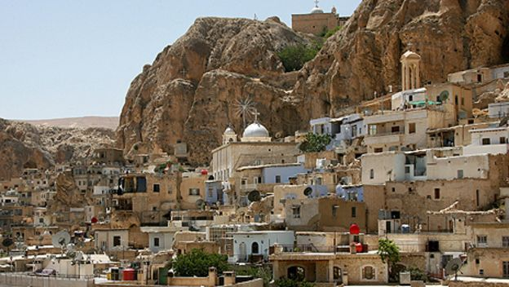

Image copyright GETTY IMAGES Image caption Syria has a sizeable Christian community

**2009**March - Jeffrey Feltman, acting assistant US secretary of state for the Near East, visits Damascus with White House national security aide Daniel Shapiro in first high-level US diplomatic mission for nearly four years. Meets Foreign Minister Walid Muallem.

Trading launches on Syria's stock exchange in a gesture towards liberalizing the state-controlled economy.

**2010**May - US renews sanctions against Syria, saying that it supports terrorist groups, seeks weapons of mass destruction and has provided Lebanon's Hezbollah with Scud missiles in violation of UN resolutions.

**Nationwide uprising**

**2011**March - Security forces shoot dead protestors in southern city of Deraa demanding release of political prisoners, triggering violent unrest that steadily spread nationwide over the following months.

**2011 protests**

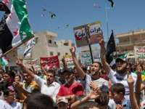

Image copyright AFP

Pro-democracy protests erupted in 2011; the government responded with violence

President Assad announces conciliatory measures, releasing dozens of political prisoners, dismissing government, lifting 48-year-old state of emergency.

**2011**May - Army tanks enter Deraa, Banyas, Homs and suburbs of Damascus in an effort to crush anti-regime protests. US and European Union tighten sanctions.

**2011**June - The IAEA nuclear watchdog decides to report Syria to the UN Security Council over its alleged covert nuclear program reactor program. The structure housing the alleged reactor was destroyed in an Israeli air raid in 2007.

**Opposition organizes**

**2011**July - President Assad sacks the governor of the northern province of Hama after mass demonstration there, eventually sending in troops to restore order at the cost of scores of lives.

**2011** October - New Syrian National Council says it has forged a common front of internal and exiled opposition activists.

**2011**November - Arab League votes to suspend Syria, accusing it of failing to implement an Arab peace plan, and imposes sanctions.

**Civil war**

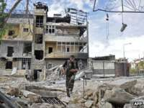

Image copyright AFP

The uprising against President Assad gradually turned into a full-scale civil war

**2012**February - Government steps up the bombardment of Homs and other cities.

**2012**March - UN Security Council endorses non-binding peace plan drafted by UN envoy Kofi Annan. China and Russia agree to support the plan after an earlier, tougher draft is modified.

**Opposition rifts**

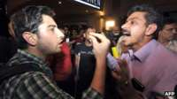

Image copyright AFP

Divisions and concern about the role of Islamists have bedeviled the opposition

[**Guide to the Syrian opposition**](http://www.bbc.com/news/world-middle-east-15798218)

**2012**June - Turkey changes rules of engagement after Syria shoots down a Turkish plane, declaring that if Syrian troops approach Turkey's borders they will be seen as a military threat.

**2012**July - Free Syria Army blows up three security chiefs in Damascus and seizes Aleppo in the north.

**2012**August - Prime Minister Riad Hijab defects, US President Obama warns that use of chemical weapons would tilt the US towards intervention.

**2012**October - Fire in Aleppo destroys much of the historic market as fighting and bomb attacks continue in various cities.

**2012** November - National Coalition for Syrian Revolutionary and Opposition Forces formed in Qatar, excludes Islamist militias. Arab League stops short of full recognition.

**2012**December - US, Britain, France, Turkey and Gulf states formally recognize opposition National Coalition as "legitimate representative" of Syrian people.

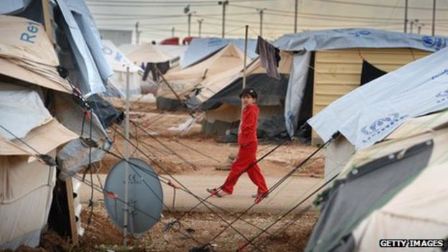

Image copyright GETTY IMAGES Image caption The conflict in Syria displaced millions of people, many of whom sought refuge in camps in Jordan, Turkey and Lebanon

**2013**January - Syria accuses Israel of bombing military base near Damascus, where Hezbollah was suspected of assembling a convoy of anti-aircraft missiles bound for Lebanon.

**Chemical arms claims**

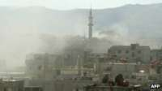

Image copyright AFP

Government forces have faced - and denied - repeated allegations of chemical weapons use

**Rise of Islamists**

**2013** September - UN weapons inspectors conclude that chemical weapons were used in an attack on the Ghouta area of Damascus in August that killed about 300 people, but do not allocate responsibility. Government allows UN to destroy chemical weapons stocks, process complete by June 2014.

**2013**December - US and Britain suspend "non-lethal" support for rebels in northern Syria after reports that Islamist rebels seized bases of Western-backed Free Syrian Army.

**2014**January-February - UN-brokered peace talks in Geneva fail, largely because Syrian authorities refuse to discuss a transitional government.

**2014**March - Syrian Army and Hezbollah forces recapture Yabroud, the last rebel stronghold near the Lebanese border.

**2014**June - Islamic State of Iraq and Syria militants declare "caliphate" in territory from Aleppo to eastern Iraqi province of Diyala.

**2014**September - US and five Arab countries launch air strikes against Islamic State around Aleppo and Raqqa.

**2015**January - Kurdish forces push Islamic State out of Kobane on Turkish border after four months of fighting.

**2015**May - Islamic State fighters seize the ancient city of Palmyra in central Syria and proceed to destroy many monuments at pre-Islamic World Heritage site.

Jaish al-Fatah (Army of Conquest) Islamist rebel alliance takes control of Idlib Province, putting pressure on government's coastal stronghold of Latakia.

**Russian intervention**

**2015**September - Russia carries out its first air strikes in Syria, saying they target the Islamic State group, but the West and Syrian opposition say it overwhelmingly targets anti-Assad rebels.

**2015**December - Syrian Army allows rebels to evacuate remaining area of Homs, returning Syria's third-largest city to government control after four years.

**2016**March - Syrian government forces retake Palmyra from Islamic State with Russian air assistance, only to be driven out again in December.

**2016**August - Turkish troops cross into Syria to help rebel groups push back so-called Islamic State militants and Kurdish-led rebels from a section of the two countries' border.

**2016**December - Government troops, backed by Russian air power and Iranian-sponsored militias, recaptures Aleppo, the country's largest city, depriving the rebels of their last major urban stronghold.

**2017**January - Russia, Iran and Turkey agree to enforce a ceasefire between the government and non-Islamist rebels, after talks between the two sides in Kazakhstan.